**A quick overview of AI:**

Read the following article make notes and write down whatever questions you might have:

<https://medium.com/appanion/a-five-minute-guide-to-artificial-intelligence-c4262be85fd3>

What is A.I.?

In which parts of A.I. are you interested?

How does A.I. specifically relates to other disciplines?

**Clarification of confusing buzzwords: (Make your own map or drawing and include it in your notes)**

Machine learning

[Topology of Machine Learning](https://i.imgur.com/mZdJLdg.png)

[Uses of Machine Learning](https://nordcloud.com/wp-content/uploads/2018/06/Machine-learning-categories-.png)

[Scikit Decision Map](https://scikit-learn.org/stable/tutorial/machine_learning_map/)

<https://en.wikipedia.org/wiki/Timeline_of_machine_learning>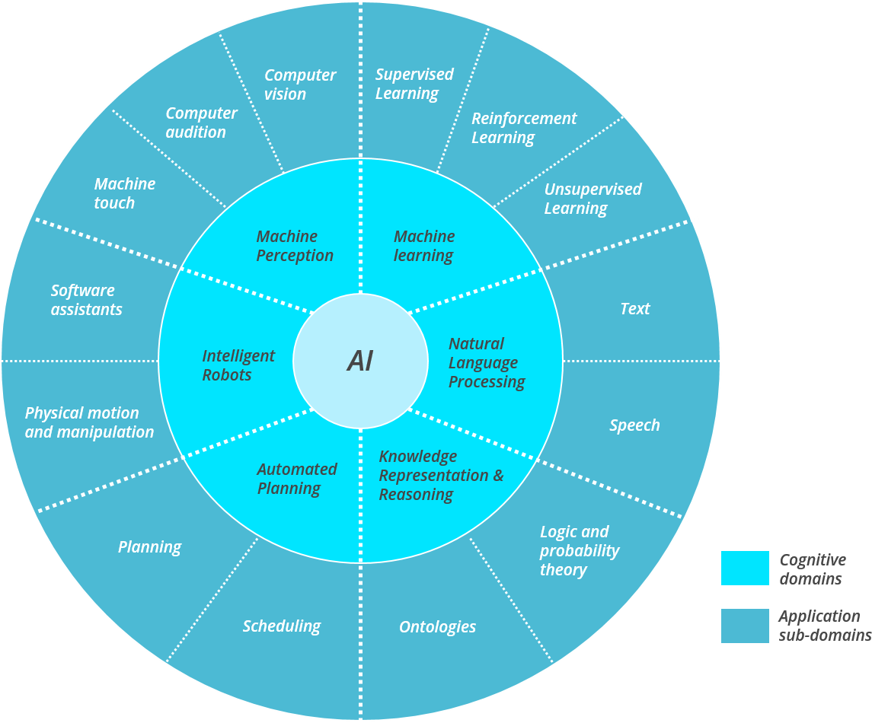

Data Science

[Uses of Data Science](https://miro.medium.com/max/1248/1*9axuA4i8yQcrbq3diE57AA.png)

Agents (Robots)

[Agent architectures](https://media.geeksforgeeks.org/wp-content/uploads/art1.png)

**Data sets**:

The difference between data, information and knowledge.

[Facts, indicators and explanations.](https://www.knowledgebase-script.com/kb/assets/knowledge-pyramid.png)

Why do we care?

What is a data set?

How is it used?

1. Learn “stuff” new insights
2. Automate a process

Let's look at a dataset, go to your google drive, make a folder and upload there the contents of the folder “intro to AI”

Open with Google Colab the Loading Data set.ipynb notebook and follow the process step by step with you instructor.

Grant access to your folder

Check dataset in .csv’s

Load data set into dataframe.

Set names of columns

Select the columns of interest.

**Exercise:** Now follow the same process to create your own jupyter notebook and load the wine data set, then filter the data to as to get only a dataframe with the following columns:

1) Alcohol

2) Malic acid

3) Ash

10) Color intensity

11) Hue

**Charts**

Why make charts (visualizations)?

Help to quickly identify patterns in data, such as correlations,

Identify outliers

Possible clusters

Trend in timelines

Open with Google Colab the Loading Data set.ipynb notebook and follow the process step by step with you instructor.

Grant access to your folder

Check dataset in .csv’s

Load data set into dataframe.

Set names of columns

Plot columns of interest.

**Exercise:** Now follow the same process to create your own jupyter notebook and load the wine data set, then visualize different attributes of the data set and try to find patterns amongst the data.